

Lab Report

|  |  |  |  |  |  |  |
| --- | --- | --- | --- | --- | --- | --- |
| **Only for course Teacher** | | | | | | |
|  | | **Needs Improvement** | **Fair** | **Good** | **Excellent** | **Total Mark** |
| **Allocate mark & Percentage** | | **25%** | **50%** | **75%** | **100%** | **25** |
| **Understanding/Analysis** | **7** |  |  |  |  |  |
| **Implementation** | **8** |  |  |  |  |  |
| **Report Writing** | **10** |  |  |  |  |  |
| **Total obtained mark** | | | | | |  |
| **Comments** |  | | | | | |

**Semester: Fall 24**

**Submission Date: 13/11/2024**

**Course Code: SE231**

**Course Name: System Analysis and Design Capstone Project**

**Course Teacher Name: Tanzim Hossain**

**Designation: Lecturer**

**Group Member Details:**

|  |  |
| --- | --- |
| **Student ID** | **Student Name** |
| **222-35-1111** | **Nur Ahmed** |
| **222-35-1105** | **Sami Abdulllah** |
| **222-35-1120** | **Kazi Shafiul Islam** |
| **Section: 38(A2)** | |

**Table of Contents**

Contents

**Introduction** 5

**Objective** 5

**Key Features** 5

**Scenario Writing** 6

**Scenario-1: Add Profile** 6

**Scenario-2: Add Expense** 6

**Scenario-3: Set Financial Goals** 6

**Scenario-4: Financial Advice** 7

**Scenario-5: Donation** 7

**Scenario-6: Data Management** 7

**Scenario-7: Generate Reports** 8

**Scenario-8: Forget Password** 8

**Stakeholder** 9

**User Profile** 10

**User Profile-01: User** 10

**User Profile-02: Financial Advisors** 11

**User Profile-03: Admin** 12

**Scope** 13

**1.** **User Registration and Login:** 13

**2.** **Add Profile or Update Profile:** 13

**3.** **Log Daily Expenses:** 13

**4.** **Set Financial Goals:** 13

**5.** **Receive Notifications:** 13

**6.** **Generate Financial Reports:** 13

**7.** **Consultation with Financial Advisors:** 13

**8.** **Helpline:** 13

**9.** **Data Management and Security:** 13

**Feasibility Study** 14

**1.** **Technical Feasibility:** 14

**2.** **Operational Feasibility:** 14

**3.** **Economic Feasibility:** 14

**4.** **Return on Investment (ROI):** 14

**5.** **Scheduling Feasibility:** 14

**Project Block Diagram** 16

**Block Diagram-1: User** 16

**Block Diagram-2: Financial Advisor** 17

**Block Diagram-3: Admin** 18

**Software Requirement Specification** 19

**User Case Diagram** 21

**Use Case Description** 22

**Case Description-01: Registration** 22

**Case Description-02: Login** 23

**Case Description-03: Add Profile** 24

**Case Description-04: Add Expense** 25

**Case Description-05: Set Financial Goal** 26

**Case Description-06: Financial Advice** 27

**Case Description-07: Donation** 28

**Case Description-08: Data Management** 29

**Case Description-09: Generate Reports** 30

**Case Description-10: Forget Password** 31

**Case Description-11: Logout** 32

**System Design** 33

**Data Flow Diagram** 33

**Data Flow Diagram Level-0:** 33

**Data Flow Diagram Level-1:** 34

**Activity Diagram** 35

**Activity Diagram-1: Add Profile** 35

**Activity Diagram-2: Add Expense** 36

**Activity Diagram-3: Set Financial Goal** 37

**Activity Diagram-4: Financial Advice** 38

**Activity Diagram-5: Donation** 39

**Activity Diagram-6: Data Management** 40

**Activity Diagram-7: Generate Reports** 41

**Activity Diagram-8: Forget password** 42

**State Diagram** 43

**State Diagram-1: Add Profile** 43

**State Diagram-2: Add Expense** 44

**State Diagram-3: Set Financial Goal** 45

**State Diagram-4: Financial Advice** 46

**State Diagram-5: Donation** 47

**State Diagram-6: Data Management** 48

**State Diagram-7: Generate Reports** 49

**State Diagram-8: Forget password** 50

**Sequence Diagram** 51

**Sequence Diagram-1: Add Profile** 51

**Sequence Diagram-2: Add Expense** 52

**Sequence Diagram-3: Set Financial Goal** 53

**Sequence Diagram-4: Financial Advice** 54

**Sequence Diagram-5: Donation** 55

**Sequence Diagram-6: Data Management** 56

**Sequence Diagram-7: Generate Reports** 56

**Sequence Diagram-8: Forget Password** 58

**Class Diagram** 59

**ER Diagram** 60

# **Introduction**

In today’s fast paced world individuals often struggle to keep track of their spending which can lead to financial disorganization. Expense Tracker a mobile app will allow users to log and categorize their expenses, set budgets, and generate reports gaining a clear overview of their financial activities. Users have access to basic expense tracking features and benefit from additional features such as personalized financial tips and interactive budgeting sessions.

## **Objective**

The main objective of the Expense Tracker App is to help users easily track and manage their daily expense. By integrating key functionalists, the system aims to optimize users daily spending. The app aims to improve users understanding of their spending and help them make better financial decisions.

## **Key Features**

* **Expense Logging:** The system allows users to easily record and categorize their daily expenses.
* **Budget Tracking:** User will be able to set monthly budgets and the system will monitor spending to stay with limits. If user wants to save some money the system will advise the user spend carefully so he will be able to save money.
* **Expense Reports:** The system will generate reports on user expenses which he can have on a daily, monthly, yearly basis that will show the user his spending patterns. If the report shows the expense is closing up to the limit, system will give user warnings to spend less money.
* **User Tiers:** Regular users have access to basic features. Premium user will have few extra features with the basic features.
* **Tips:** Users receive personalized financial tips to improve money management.
* **Planning Sessions:** Users can access financial planning sessions for better budgeting.
* **Have You Spend Any**: Many times, in a rush the user might forget to log his spending, to solve this problem the system will ask the if he had any spending after a specific time gap, the time gap can be customized by the user.

# **Scenario Writing**

Scenario writing involves describing specific situations or use cases that illustrate how a system or software application will be used by its users. These scenarios help to better understand the system's functionalities, interactions, and outcomes. In the context of the Daily Expense Tracker App, let's write some scenarios to depict typical user interactions:

### **Scenario-1: Add Profile**

Scenario Description:

Request to add a new profile

Provide necessary profile details (e.g., name, email, password, etc.)

Complete and confirm all required fields

Submit to create profile

Profile addition successful notification

### **Scenario-2: Add Expense**

Scenario Description:

Request to add a new expense

Enter expense details (e.g., amount, category, date, description)

Select expense category (e.g., food, transport, utilities)

Review and confirm details

Submit to log expense

Expense addition successful notification

### **Scenario-3: Set Financial Goals**

Scenario Description:

Request to set financial goals

Specify goal details (e.g., saving amount, target date)

Define relevant goal parameters (e.g., daily/weekly spending limits)

Review and confirm goal settings

Submit to save financial goal

Goal set successfully notification

### **Scenario-4: Financial Advice**

Scenario Description:

Request for financial advice

Provide current financial status (e.g., income, recent expenses, goals)

System analyzes financial data

Receive personalized financial advice

Display advice and recommendations to the user

### **Scenario-5: Donation**

Scenario Description:

Request to record a donation

Enter donation details (e.g., amount, recipient, date)

Choose donation category or purpose

Confirm donation details

Submit to log donation

Donation logged successfully notification

### **Scenario-6: Data Management**

Scenario Description:

Request to manage data

Choose data management action (e.g., update, delete, view history)

Select relevant data entry (e.g., specific expense, goal, profile info)

Perform the action on selected data

Data management action completed notification

### **Scenario-7: Generate Reports**

Scenario Description:

Request to generate financial reports

Select report type (e.g., monthly expense, goal progress, category summary)

Define report parameters (e.g., date range)

System processes and compiles report

Display report to the user

Report generation successful notification

### **Scenario-8: Forget Password**

Scenario Description:

Request password reset

Provide registered email or username

System verifies account information

Receive password reset instructions via email or SMS

Reset password and submit

Password reset successful notification

# **Stakeholder**

The key stakeholders that are involved in this Daily Expense Tracker App:

1. **User:** They interact with the system in order to log their daily expenses, view the insights of their daily financial activity, set financial goals and consult with the experts.
2. **Financial Advisor:** They use the system to engage with the users.
3. **Admin:** They have elevated privileges to manage the system, provide helpline support.

# **User Profile**

## **User Profile-01: User**

|  |  |  |
| --- | --- | --- |
| **User Class** | **Notes on Characteristic** | **Requirement Implied** |
| Type of User | User | Verification |
| Age Range | 15-70 | Verification |
| Frequency of Use | Multiple times daily | Performance,  Operation,  Usability |
| Mandatory | Yes | Interface, Notification System |
| Computer Experience | No |  |
| Goals | Track expenses, manage budget, achieve financial stability | Resource, Performance, Security, Data Privacy |
| Language Skills | Bangla, English | Localization, Usability |
| Number of Users | 100-1000 | Performance, Scalability, Usability |
| Training | No |  |
| Other System Used | No |  |
| Ways of Working | Requires timely notifications and easy access to data | Performance, Security, Operation, Maintenance, Portability |

## **User Profile-02: Financial Advisors**

|  |  |  |
| --- | --- | --- |
| **User Class** | **Notes on Characteristic** | **Requirement Implied** |
| Type of User | Financial Advisor | Verification |
| Age Range | 30-50 | Verification |
| Frequency of Use | Few times daily (consultations, accessing reports) | Performance,  Operation,  User Access Management |
| Mandatory | Yes | Security, Data Privacy, Role-based Access |
| Computer Experience | Experienced | Advanced Reporting, Analysis Tools |
| Education | B.Sc. in Finance, Economics, or related field |  |
| Goals | Provide financial advice,  Manage consultations,  Analyze user data | Performance, Security, Acceptance, Reporting |
| Language Skills | Bangla, English |  |
| Number of Users | 10-15 | Performance, User Management, Privacy |
| Training | May require specific training for the app’s analytical tools | Documentation, Training Modules, Support |
| Other System Used | No |  |
| Ways of Working | Needs detailed analytics, data privacy, and secure access | Security, Operation, Maintenance, Data Integrity, Portability |

## **User Profile-03: Admin**

|  |  |  |
| --- | --- | --- |
| **User Class** | **Notes on Characteristic** | **Requirement Implied** |
| Type of User | Admin | Verification, Administration |
| Age Range | 25-45 | Verification |
| Frequency of Use | Regular use for monitoring, user management, and troubleshooting | Performance, Operation, Security |
| Mandatory | Yes |  |
| Computer Experience | Highly Experienced | Advanced System Operations, Security Management |
| Education | B.Sc. in Computer Science or Information Technology |  |
| Goals | Ensure smooth operation, user management, and data security | Resource Management, Performance, Security, Maintenance |
| Language Skills | Bangla, English, and Computer Languages |  |
| Number of Users | 1-5 | Scalability, System Management, Performance |
| Training | Some training for handling backend operations and security aspects | Documentation, Continuous Training, Support |
| Other System Used | No |  |
| Ways of Working | Needs full control and visibility over system operations | Security, System Maintenance, High Availability, Portability |

# **Scope**

## **User Registration and Login:**

* 1. **Objective:** Allow users to register and log in to the system.
  2. **Functionality:** Users will provide necessary information for registration. Secure authentication mechanisms will be implemented for user logins. Password recovery options will be available.

## **Add Profile or Update Profile:**

* 1. **Objective:** Enable users to create and update their profiles inside the system.
  2. **Functionality:** Users can enter and store personal details. Update profile information, such as contact details or preferences.

## **Log Daily Expenses:**

* 1. **Objective:** Allow users to log and categorize their daily expenses efficiently.
  2. **Functionality:** Users can add expense entries by specifying the amount, date, and category (e.g., food, transport, entertainment).

## **Set Financial Goals:**

* 1. **Objective:** Enable users to set financial goals.
  2. **Functionality:** Users can set daily, weekly, or monthly financial limits.

## **Receive Notifications:**

* 1. **Objective:** Enable users to receive notifications for unusual transactions.
  2. **Functionality:** The system will send notifications if spending exceeds the set limits.

## **Generate Financial Reports:**

* 1. **Objective:** Provide users with insightful reports and summaries of their financial activities.
  2. **Functionality:** The app will automatically generate daily, weekly, and monthly insights of expenses as Graphs, charts, and tables.

## **Consultation with Financial Advisors:**

* 1. **Objective:** Allows users to consult with expert financial advisors.
  2. **Functionality:** Users can view the profiles and availability of financial advisors inside the app with a low consultation fee.

## **Helpline:**

* 1. **Objective:** Offer 24/7 customer support within the system.
  2. **Functionality:** Provide a helpline feature for customers to seek assistance. Access to FAQs and common issues resolution.

## **Data Management and Security:**

* 1. **Objective:** Ensure the security of user data and financial transactions.
  2. **Functionality:** Implement secure socket layer (SSL) for data encryption. Secure user authentication and authorization. Regularly update and patch system vulnerabilities.

# **Feasibility Study**

The Daily Expense Tracker app aims to provide a comprehensive solution to help users monitor their daily spending habits efficiently and maintain financial stability. This feasibility study assesses the viability of implementing the app by analyzing its technical, operational, economic, and scheduling aspects.

## **1. Technical Feasibility:**

* **Hardware Compatibility:** The DET app is designed for smartphones, requiring compatibility with common hardware standards for Android and iOS devices.
* **Software Compatibility:** The app must integrate with mobile operating systems (Android and iOS), It has to work with existing financial APIs for transaction tracking.
* **Technical Expertise:** The developer time must make it user friendly so that potential consumer can use it. There should be training manual for user and financial advisor so that they can find guideline.

## **2. Operational Feasibility:**

* **User Acceptance:** Gather feedback from potential users specially student and small business owners, to ensure the system aligns with their needs and expectations.
* **Impact on Current Operations:** Analyze does it’s more reliable than the orthodox approach.
* **Support for Financial Advisors:** The app will provide tools for Financial Advisors to offer personalized advice to premium users, which will require collaboration with financial experts to ensure the app meets professional standards and guidelines.

## **3. Economic Feasibility:**

* **Cost-Benefit Analysis:** Conduct a thorough analysis of the costs associated with developing, implementing, and maintaining the DET app. Where the main earing source is from donation and ads.

**4. Return on Investment (ROI):**

* Projected ROI will be calculated based on user donation, potential ad revenue. The analysis will account for both tangible and intangible benefits over a specified period.

## **5. Scheduling Feasibility:**

* **Project Timeline:** Develop a realistic timeline for the different phases of the DET implementation will be analyzed by the developer. They’ll consider taking into account potential delays, testing periods, and staff training.
* **Dependencies:** Identify dependencies on external factors, such as third-party integrations or regulatory approvals that may impact the project schedule.

The feasibility study concludes that the Daily Expense Tracker app is technically, operationally, economically, and schedulable viable. The anticipated benefits of enhanced financial tracking, improved user financial health, and potential revenue from premium features outweigh the costs associated with development and implementation. Recommendations for mitigating risks, such as data security measures and user support systems, will be incorporated into the project plan to ensure the successful deployment of the Daily Expense Tracker app.

# **Project Block Diagram**

## **Block Diagram-1: User**

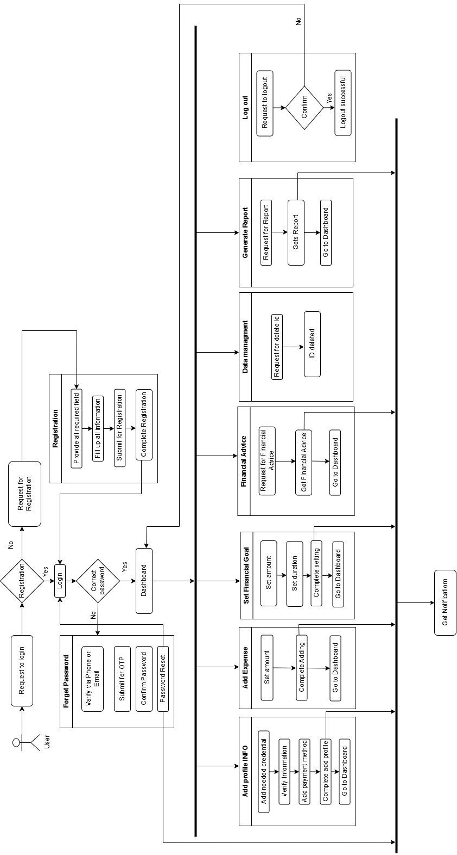

**Figure-1: Block Diagram for User**

## **Block Diagram-2: Financial Advisor**

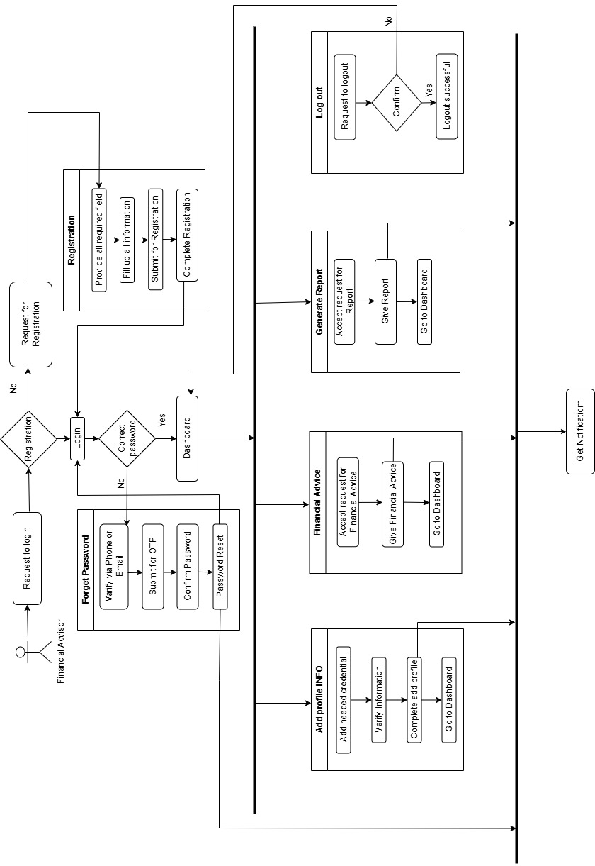

**Figure-2: Block Diagram for Financial Advisor**

## **Block Diagram-3: Admin**

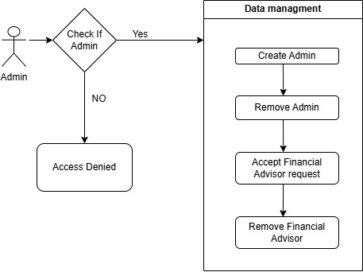

**Figure-3: Block Diagram for Admin**

# **Software Requirement Specification**

|  |  |
| --- | --- |
| **FR01** | **Registration** |
| **Description** | Users, including users and advisor must register before using the Daily Expense Tracker app. |
| **Stakeholder** | User, Financial Advisor |

|  |  |
| --- | --- |
| **FR02** | **Login** |
| **Description** | Users, including users and advisors must log in before accessing the DET app's features. |
| **Stakeholder** | User, Financial Advisor |

|  |  |
| --- | --- |
| **FR03** | **Add Profile** |
| **Description** | Customers and Advisors will add his/ her info to the system |
| **Stakeholder** | User, Financial Advisor. |

|  |  |
| --- | --- |
| **FR04** | **Add Expense** |
| **Description** | Users can add their daily expenses by entering the amount, category, and a brief description. |
| **Stakeholder** | User |

|  |  |
| --- | --- |
| **FR05** | **Set Financial Goals** |
| **Description** | Users can set financial goals, such as monthly savings targets or spending limits in various categories. |
| **Stakeholder** | User |

|  |  |
| --- | --- |
| **FR06** | **Financial Advice** |
| **Description** | Users can receive personalized financial advice and recommendations from Financial Advisors based on their spending data. |
| **Stakeholder** | User, Financial Advisor. |

|  |  |
| --- | --- |
| **FR07** | **Donation** |
| **Description** | Users can donate money. It is up to them and services aren’t depending on it |
| **Stakeholder** | User |

|  |  |
| --- | --- |
| **FR08** | **Data Management** |
| **Description** | Users can manage their data, including adding, editing, or deleting their expense entries and profile information. |
| **Stakeholder** | User, Admin |

|  |  |
| --- | --- |
| **FR09** | **Generate Reports** |
| **Description** | The system generates daily, weekly, and monthly reports in the form of graphs and tables to provide insights into the user's spending habits. |
| **Stakeholder** | User |

|  |  |
| --- | --- |
| **FR10** | **Forget Password** |
| **Description** | If any user forgets their password, then they can easily recover his/her password. |
| **Stakeholder** | User, Financial Advisor |

|  |  |
| --- | --- |
| **FR011** | **Logout** |
| **Description** | User can Logout from the app via this. |
| **Stakeholder** | User, Financial Advisor |

## **User Case Diagram**

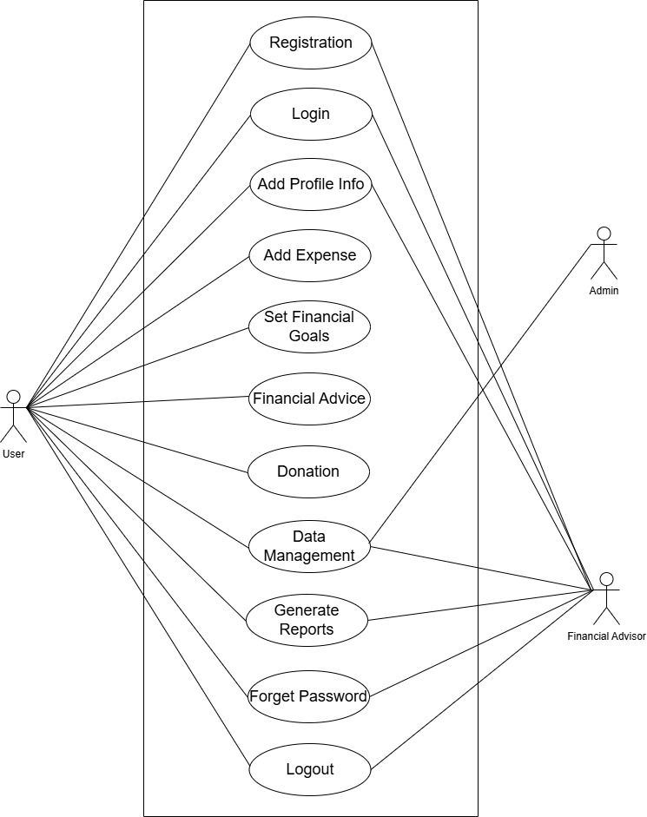

**Figure-4: User Case Diagram for Daily Expense Tracker**

## **Use Case Description**

### **Case Description-01: Registration**

|  |  |
| --- | --- |
| Use Case | Registration |
| Goal | Users can register to sign in to the system. |
| Precondition | Users must install the Daily Expense Tracker app for registration. |
| Success End Condition | Notification: !!!Successfully Registered!!! |
| Failed End Condition | Notification: “Submission Not Submitted” |
| Primary Actors:  Secondary Actors: | Customer |
| Trigger | User will request a registration form to fill up |
| Description / Main Success  Scenario | 1. Press “Registration” Button  |  |  | | --- | --- | | 1.1 | System Error | |  | 1.1.a. Try Again!! | | 2.1 | System Doesn't work. | |  | 2.1.a. Try Again Later! | | 4.1 | The user Did not fill up the details! | |  | 4.1.a. Checked By the system & Notify by “Please! Fill Up the Box”. | | 5.1 | The system did not respond | |  | 5.1.a. Show Error Message. | | 6.1 | The system Doesn’t save the details. | |  | 6.1.a. Notification: “Details did not Save” |  |  |  | | --- | --- | |  |  | |  |  | |  |  | |  |  | |  |  | |  |  | |  |  |  |  |  | | --- | --- | |  |  | |  |  | |  |  | |  |  | |  |  | |  |  | |  |  | |  |  | |  |  | |  |  |  1. Provide registration form 2. Enter Information 3. Press “Submit” Button. 4. Information saved 5. The system saves the details and shows them !!!Successfully Registered!!! Notify |
| Alternative Flows |  |
| Quality Requirements | The user Will fill up all the details in 30 minutes. |

### **Case Description-02: Login**

|  |  |  |  |  |
| --- | --- | --- | --- | --- |
| Use Case | Login | | | |
| Goal | Users can enter the system by the login. | | | |
| Precondition | Users must have to be registered First. | | | |
| Success End Condition | Notification: “Login Successful” | | | |
| Failed End Condition | Notification: “Login Failed!!” | | | |
| Primary Actors:  Secondary Actors: | Customer, Manager  Admin | | | |
| Trigger | The user will request a login to enter the system | | | |
| Description / Main Success  Scenario |  | | | |
|  | 1. | Press “Login” Button |  |
| 2. | Provide login interface |  |
| 3. | Enter user id and password. |  |
| 4. | User provide the “Login” button |  |
| 5. | Verified and login |  |
| 6. | Notification: “Login Successful” |  |
| Alternative Flows |  | | | |
|  | 1.1 | System Error |  |
|  | 1.1.a. Try again |  |
| 2.1 | Server Not Found |  |
|  | 2.1.a. Try Again Later! |  |
| 4.1 | The system Did not respond. |  |
|  | 4.1.a. Show error message. |  |
| 5.1 | Information Error!! |  |
|  | 5.1.a. Notification: “Enter the right User ID and Password.” |  |
| Quality Requirements | Users fill up the login info within 10 minutes. | | | |

### **Case Description-03: Add Profile**

|  |  |  |  |  |
| --- | --- | --- | --- | --- |
| Use Case | Add Profile Info | | | |
| Goal | Adding the required information to create an account. | | | |
| Precondition | The user must log in to the system. | | | |
| Success End Condition | Notification: “Added Info Successfully” | | | |
| Failed End Condition | Notifications: “Submission Not Submitted” | | | |
| Primary Actors:  Secondary Actors: | User, Financial Advisor. | | | |
| Trigger | Users will request to add their profile information in the profile info. | | | |
| Description / Main Success  Scenario |  | | | |
|  | 1. | Visit Dashboard |  |
| 2. | Press “Added Profile Info” |  |
| 3. | Provide information field |  |
| 4. | Filled up information |  |
| 5. | User press “Submit” button |  |
| 6. | Profile info saved |  |
| Alternative Flows |  | | | |
|  | 2.1 | System Error |  |
|  | 2.1.a Try again |  |
| 3.1 | Not responding |  |
|  | 3.1.a Try later |  |
| 4.1 | Check empty field |  |
|  | 4.1.a. Field up required information |  |
| 5.1 | Info not saved |  |
|  | 5.1.a Notification: “Info Not saved” |  |
| Quality Requirements | Users have 10 minutes to fill up | | | |

### **Case Description-04: Add Expense**

|  |  |  |  |  |
| --- | --- | --- | --- | --- |
| Use Case | Add Expense | | | |
| Goal | Adding Expense so that user can get Expense track and get advices from Financial Advisor | | | |
| Precondition | The user must personalize his/her account. | | | |
| Success End Condition | Notification: “Done Adding” | | | |
| Failed End Condition | Notifications: “Invalid, Try Again” | | | |
| Primary Actors:  Secondary Actors: | User | | | |
| Trigger | Users will request to add their expense in profile. | | | |
| Description / Main Success  Scenario |  | | | |
|  | 1. | Click “Add Expense” |  |
| 2. | Press “Amount” |  |
| 3. | Provide information field (Amount of money) |  |
| 4. | Filled up information (Data and cause) |  |
| 5. | User press “Submit” button |  |
| 6. | Expense info saved |  |
| Alternative Flows |  | | | |
|  | 1.1 | System Error |  |
|  | 1.1.a Try again |  |
| 3.1 | Invalid Amount |  |
|  | 3.1.a. Put valid amount |  |
| 4.1 | Check empty field |  |
|  | 4.1.a. Field up required information |  |
| 5.1 | Info not saved |  |
|  | 5.1.a. Save in draft |  |
| Quality Requirements | Users have 10 minutes to fill up | | | |

### **Case Description-05: Set Financial Goal**

|  |  |  |  |  |
| --- | --- | --- | --- | --- |
| Use Case | Set Financial Goal | | | |
| Goal | Set financial goal so that user can get financial benefits | | | |
| Precondition | The user must add their expenses | | | |
| Success End Condition | Notification: “Setting Goal done” | | | |
| Failed End Condition | Notifications: “Invalid, Try Again” | | | |
| Primary Actors:  Secondary Actors: | User | | | |
| Trigger | Users will request to set their financial goal | | | |
| Description / Main Success  Scenario |  | | | |
|  | 1. | Click “Add Goal” |  |
| 2. | Press “Amount” |  |
| 3. | Provide information field (Amount of money) |  |
| 4. | Filled up information (Duration) |  |
| 5. | User press “Submit” button |  |
| 6. | Financial info saved |  |
| Alternative Flows |  | | | |
|  | 1.1 | System Error |  |
|  | 2.1.a Try again |  |
| 3.1 | Invalid Amount |  |
|  | 3.1.a. Put valid amount |  |
| 4.1 | Check empty field |  |
|  | 4.1.a. Field up required information |  |
| 5.1 | Info not saved |  |
|  | 5.1.a. Save in draft |  |
| Quality Requirements | Users have 10 minutes to fill up | | | |

### **Case Description-06: Financial Advice**

|  |  |  |  |  |
| --- | --- | --- | --- | --- |
| Use Case | Financial Advice | | | |
| Goal | Get financial Advice from Financial Advisor | | | |
| Precondition | The user must set their expenses and financial goal | | | |
| Success End Condition | Notification: “Your Requested advice : …” | | | |
| Failed End Condition | Notifications: “Invalid, Try Again” | | | |
| Primary Actors:  Secondary Actors: | User, financial advisor | | | |
| Trigger | Users will request to get financial advice | | | |
| Description / Main Success  Scenario |  | | | |
|  | 1. | Click “Request Advice” |  |
| 2. | Filled up information |  |
| 3. | User press “Submit” button |  |
| Alternative Flows |  | | | |
|  | 1.1 | System Error |  |
|  | 1.1.a Try again |  |
| 2.1 | Invalid Information |  |
|  | 2.1.a. Field up required information |  |
| 3.1 | Request Canceled |  |
|  | 3.1.a. Try again |  |
| Quality Requirements | Users have 10 minutes to fill up | | | |

### **Case Description-07: Donation**

|  |  |  |  |  |
| --- | --- | --- | --- | --- |
| Use Case | Donation | | | |
| Goal | Donate goods | | | |
| Precondition | The user must have and account | | | |
| Success End Condition | Notification: “Thank you for your donation.” | | | |
| Failed End Condition | Notifications: “Some error occurred, please try again.” | | | |
| Primary Actors:  Secondary Actors: | User | | | |
| Trigger | Users will request to donate | | | |
| Description / Main Success  Scenario |  | | | |
|  | 1. | Click “Make a donation” |  |
| 2. | Press “Payment Methods” |  |
| 3. | Choose a payment method |  |
| 4. | Provide information field (Amount of money) |  |
| 5. | User press “Submit” button |  |
| 6. | Donation saved |  |
| Alternative Flows |  | | | |
|  | 1.1 | System Error |  |
|  | 1.1.a Try again |  |
| 3.1 | Invalid Amount |  |
|  | 3.1.a. Put valid amount |  |
| 4.1 | Check empty field |  |
|  | 4.1.a. Field up required information |  |
| 5.1 | Info not saved |  |
|  | 5.1.a. Save in draft |  |
| Quality Requirements | Users have 20 minutes to fill up | | | |

### **Case Description-08: Data Management**

|  |  |  |  |  |
| --- | --- | --- | --- | --- |
| Use Case | Data Management | | | |
| Goal | Manage the data of the user | | | |
| Precondition | The user must have an account | | | |
| Success End Condition | Notification: “Successful.” | | | |
| Failed End Condition | Notifications: “Some error occurred, please try again.” | | | |
| Primary Actors:  Secondary Actors: | User | | | |
| Trigger | Users will request to manage their data | | | |
| Description / Main Success  Scenario |  | | | |
|  | 1. | Click “Manage Your Data” |  |
| 2. | Press “Edit or Delete” |  |
| 3. | Choose an option (Edit or Delete) |  |
| 4. | Select data |  |
| 5. | User press “Done” button |  |
| 6. | Changes have made |  |
| Alternative Flows |  | | | |
|  | 1.1 | System Error |  |
|  | 1.1.a Try again |  |
| 3.1 | Invalid Amount |  |
|  | 3.1.a. Choose valid option |  |
| 4.1 | Select valid data |  |
|  | 4.1.a. Valid data required |  |
| 5.1 | Info not saved |  |
|  | 5.1.a. Save in draft |  |
| Quality Requirements | Users have 20 minutes to fill up | | | |

### **Case Description-09: Generate Reports**

|  |  |  |  |  |
| --- | --- | --- | --- | --- |
| Use Case | Generate Reports | | | |
| Goal | Generating financial reports | | | |
| Precondition | The user must have used the application for sometime | | | |
| Success End Condition | Notification: “Your financial report.” | | | |
| Failed End Condition | Notifications: “No report to show, please try again.” | | | |
| Primary Actors:  Secondary Actors: | User | | | |
| Trigger | Users will request to see their financial report | | | |
| Description / Main Success  Scenario |  | | | |
|  | 1. | Click “See Financial Report” |  |
| 2. | Press “Choose Month” |  |
| 3. | Choose an option |  |
| 4. | Confirm |  |
| 5. | Report Generated |  |
| Alternative Flows |  | | | |
|  | 1.1 | System Error |  |
|  | 1.1.a Try again |  |
| 2.1 | Invalid Month |  |
|  | 2.1.a. Choose valid option |  |
| 3.1 | Generating Error |  |
|  | 3.1.a. Try Again |  |
| Quality Requirements | Users have 20 minutes to fill up | | | |

### **Case Description-10: Forget Password**

|  |  |  |  |  |
| --- | --- | --- | --- | --- |
| Use Case | Forget Password | | | |
| Goal | Resetting password | | | |
| Precondition | The user must have an account | | | |
| Success End Condition | Notification: “Password has been reset.” | | | |
| Failed End Condition | Notifications: “Cannot reset password, please try again.” | | | |
| Primary Actors:  Secondary Actors: | User | | | |
| Trigger | Users will request to reset their password | | | |
| Description / Main Success  Scenario |  | | | |
|  | 1. | Click “Forget Password” |  |
| 2. | Press “Send OTP to The Phone Number” |  |
| 3. | Enter the OTP |  |
| 4. | Enter new password |  |
| 5. | Password updated |  |
| Alternative Flows |  | | | |
|  | 1.1 | System Error |  |
|  | 1.1.a Try again |  |
| 3.1 | Invalid OTP |  |
|  | 3.1.a. Enter the valid OTP |  |
| 5.1 | Password not updated |  |
|  | 5.1.a. Try Again |  |
| Quality Requirements | Users have 20 minutes to fill up | | | |

### **Case Description-11: Logout**

|  |  |  |  |  |
| --- | --- | --- | --- | --- |
| Use Case | Logout | | | |
| Goal | Users can Log Out from the system. | | | |
| Precondition | The user must log in to the system. | | | |
| Success End Condition | Notification: “Logout Successful”. | | | |
| Failed End Condition | Notification: “System Error”. | | | |
| Primary Actors:  Secondary Actors: | Customer, Manager  Admin | | | |
| Trigger | The user will request a Logout | | | |
| Description / Main Success  Scenario |  | | | |
| Alternative Flows |  | | | |
|  | 1.1 | Server down |  |
|  | 1.1.a try again |  |
| 2.1 | Not Responding |  |
|  | 2.1.a Try again |  |
| 3.1 | Not Responding |  |
|  | 3.1.a Reload |  |
| Quality Requirements | The user will Immediately Logout After hitting the Logout Button. | | | |

# **System Design**

## **Data Flow Diagram**

### **Data Flow Diagram Level-0:**

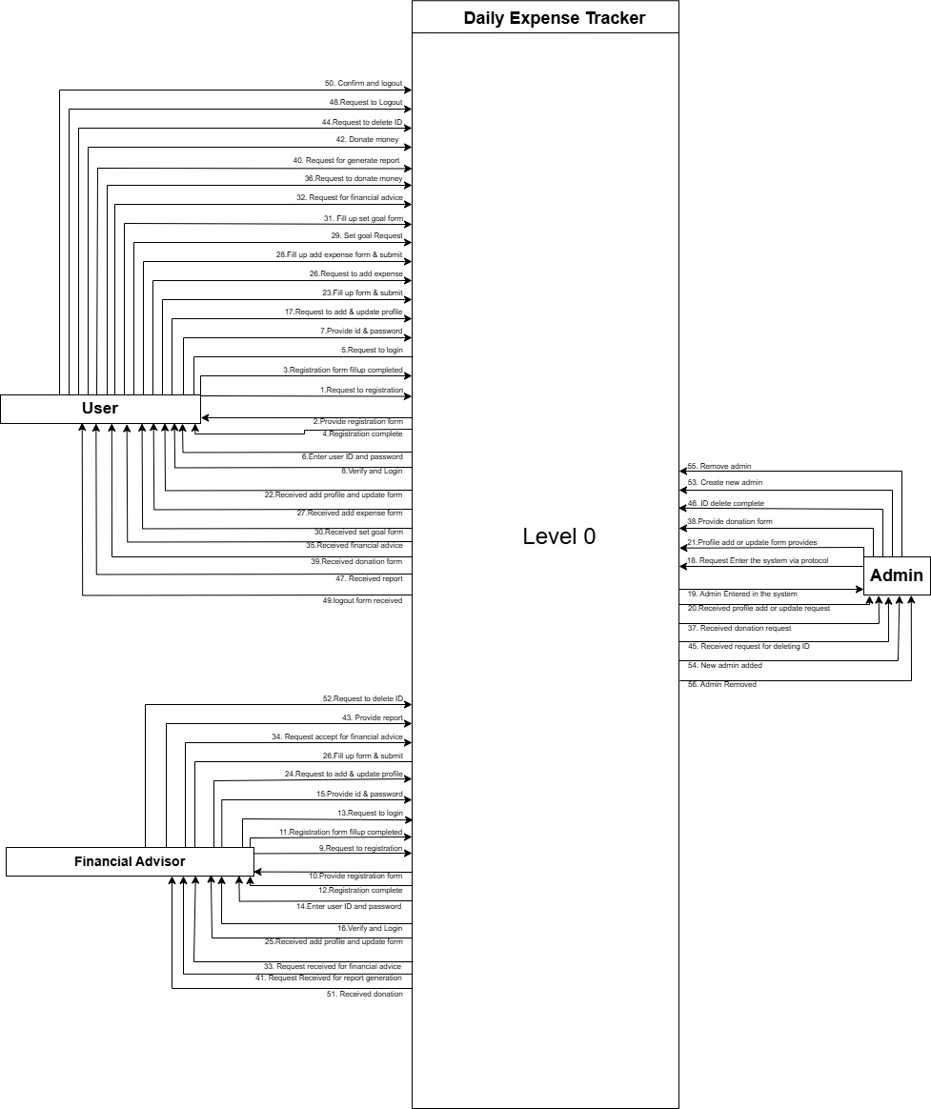

**Figure-5: Data Flow Diagram Level 0**

### **Data Flow Diagram Level-1:**

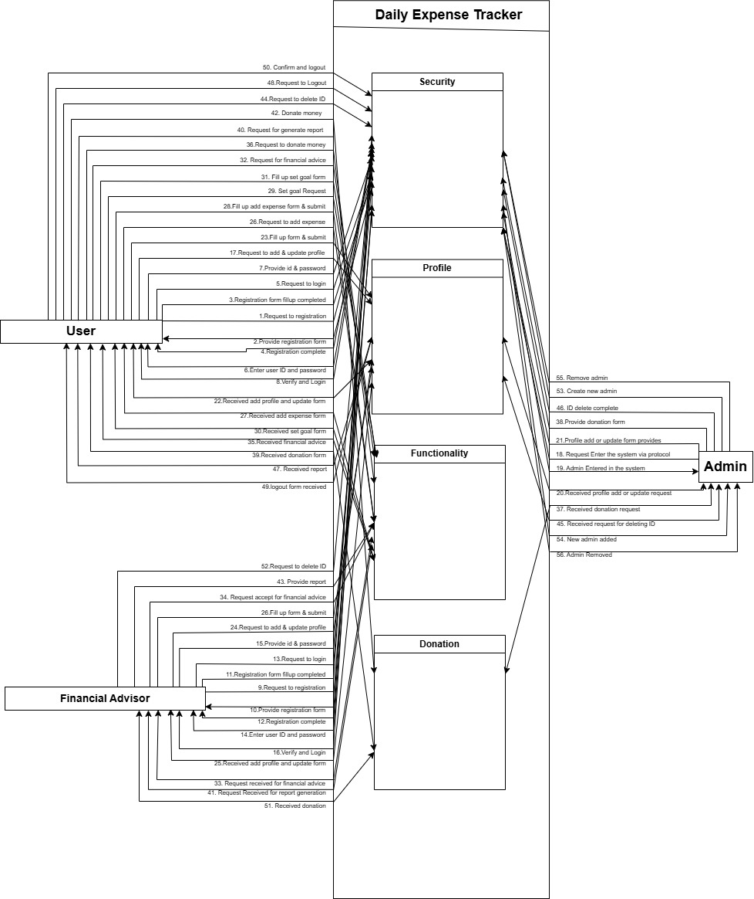

Level 1

**Figure-6: Data Flow Diagram Level 1**

## **Activity Diagram**

### **Activity Diagram-1: Add Profile**

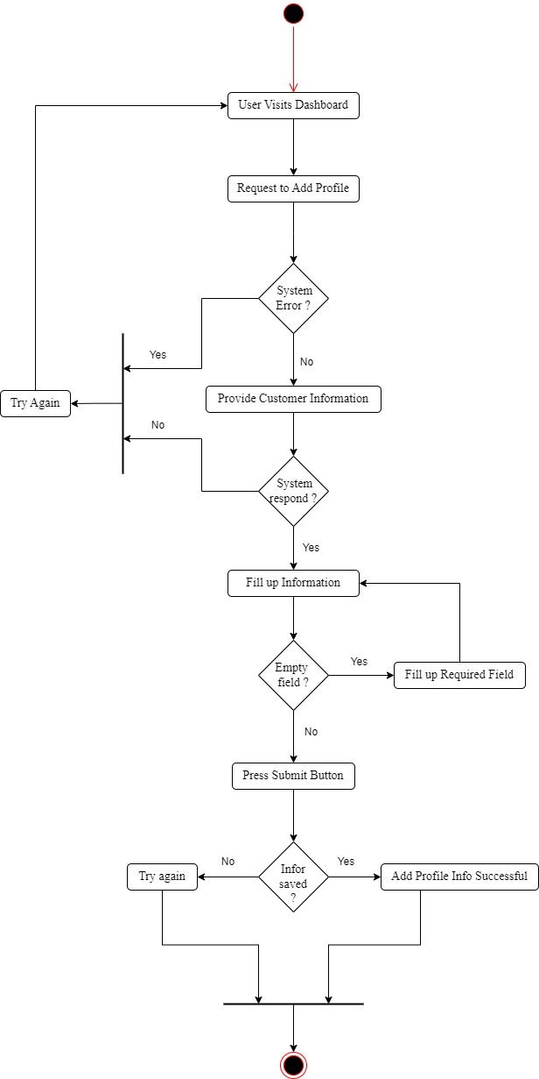

### **Activity Diagram-2: Add Expense**

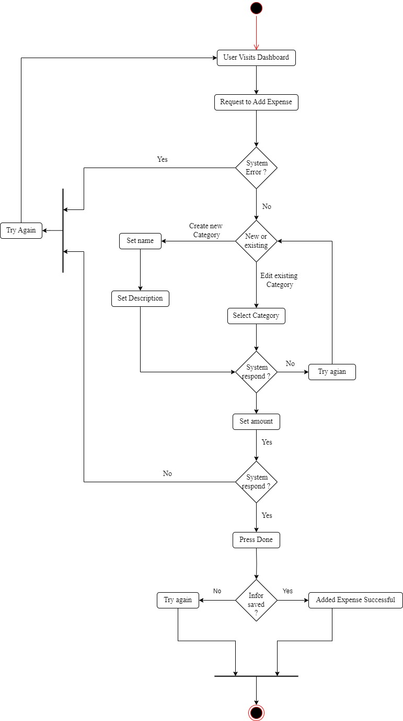

### **Activity Diagram-3: Set Financial Goal**

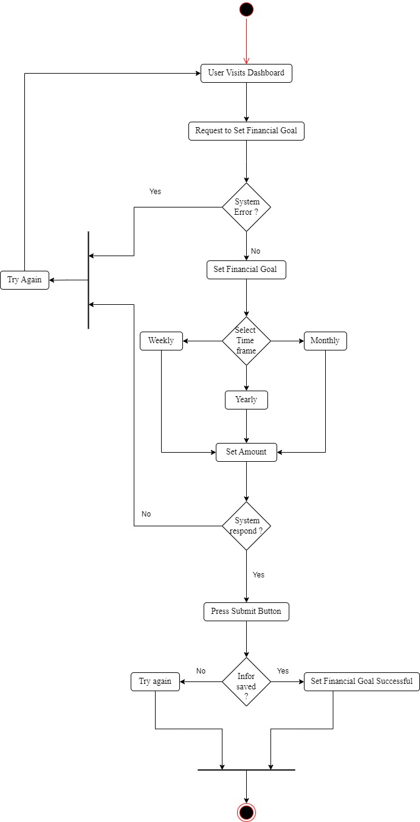

### **Activity Diagram-4: Financial Advice**

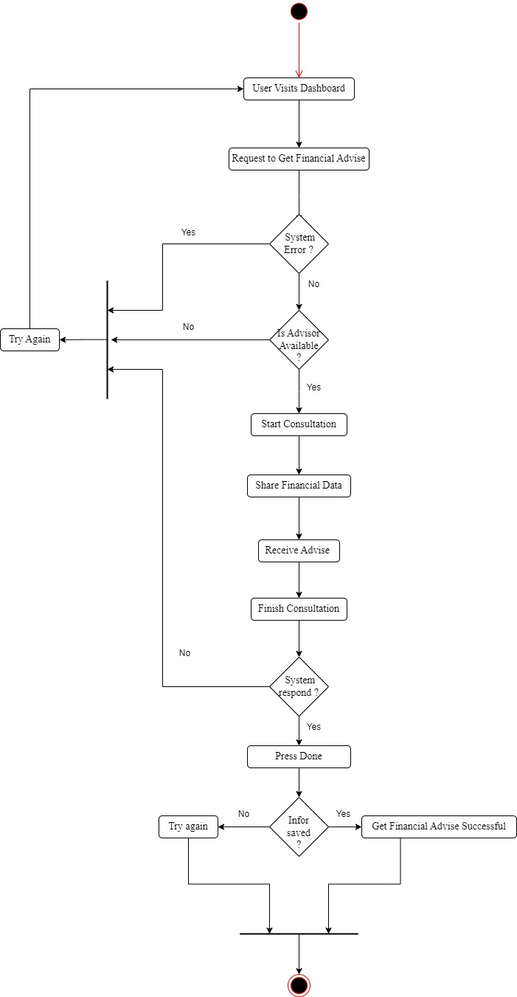

### **Activity Diagram-5: Donation**

### 

### **Activity Diagram-6: Data Management**

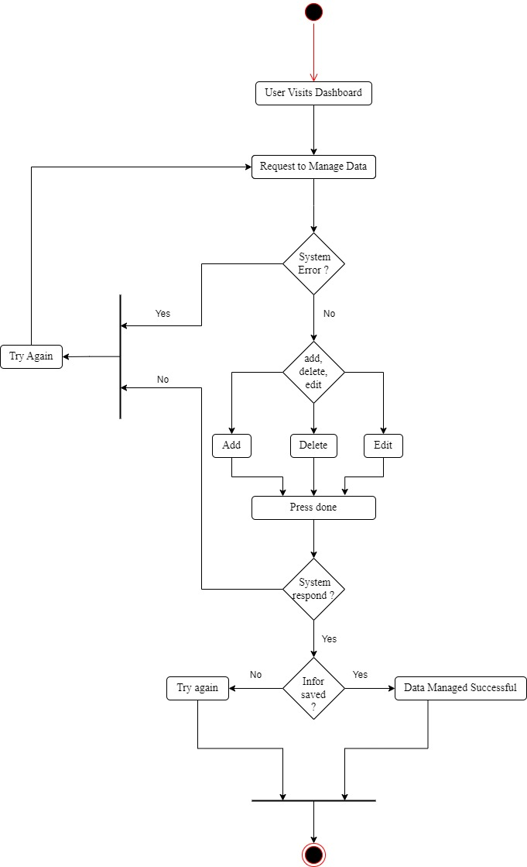

### **Activity Diagram-7: Generate Reports**

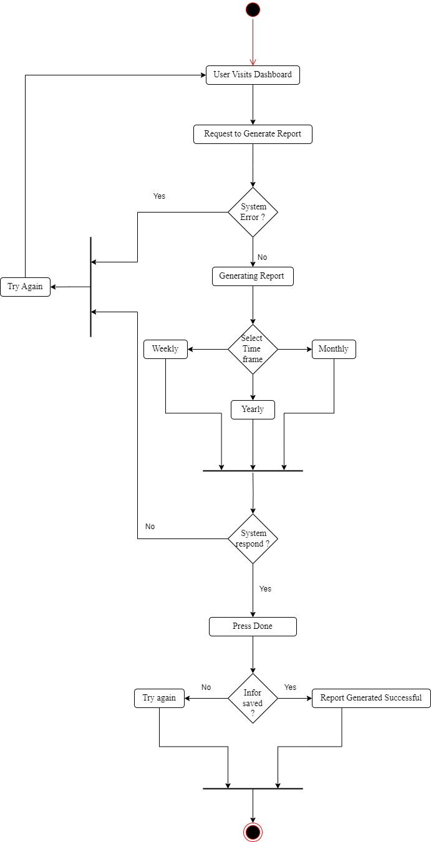

### **Activity Diagram-8: Forget password**

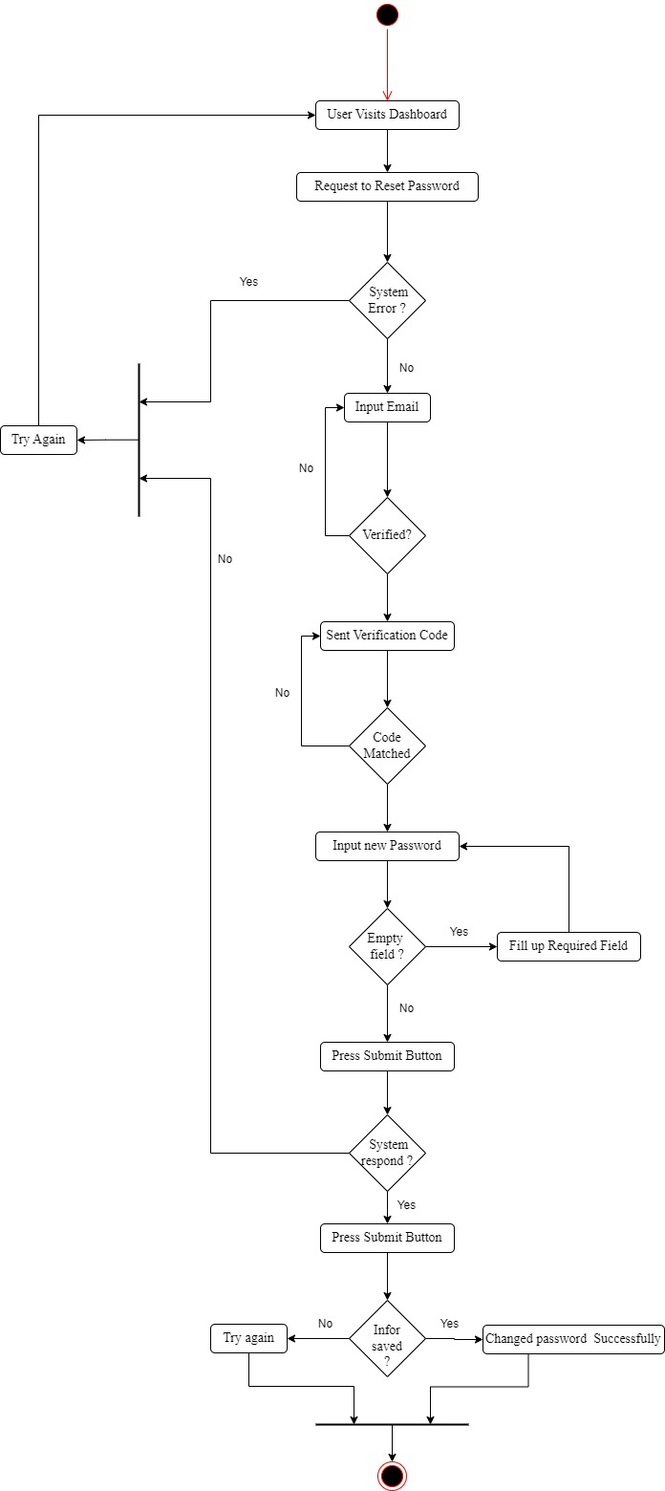

## **State Diagram**

### **State Diagram-1: Add Profile**

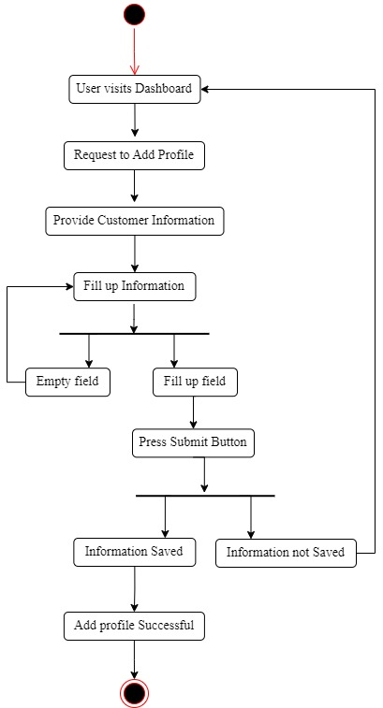

### **State Diagram-2: Add Expense**

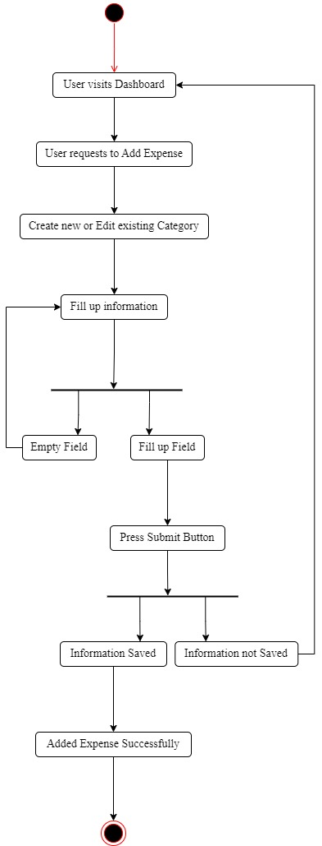

### **State Diagram-3: Set Financial Goal**

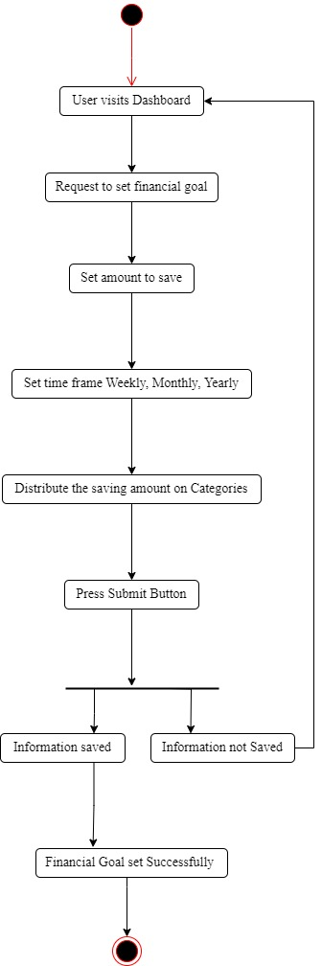

### **State Diagram-4: Financial Advice**

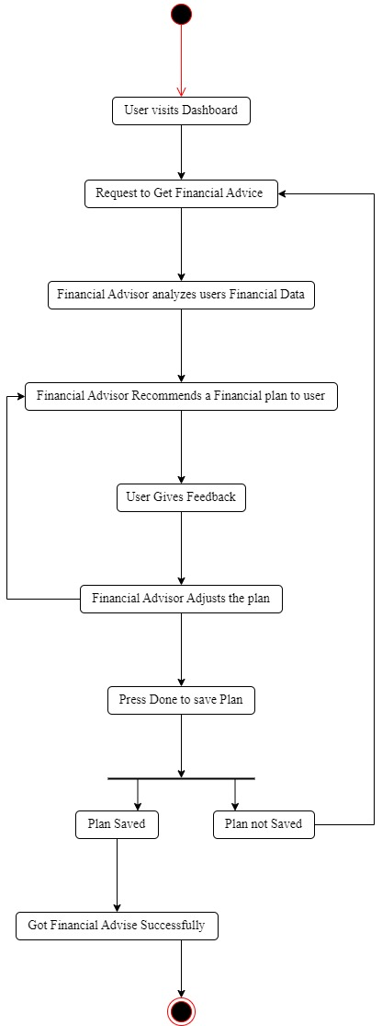

### **State Diagram-5: Donation**

### 

### **State Diagram-6: Data Management**

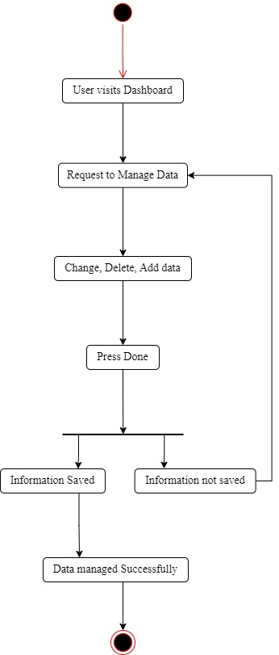

### **State Diagram-7: Generate Reports**

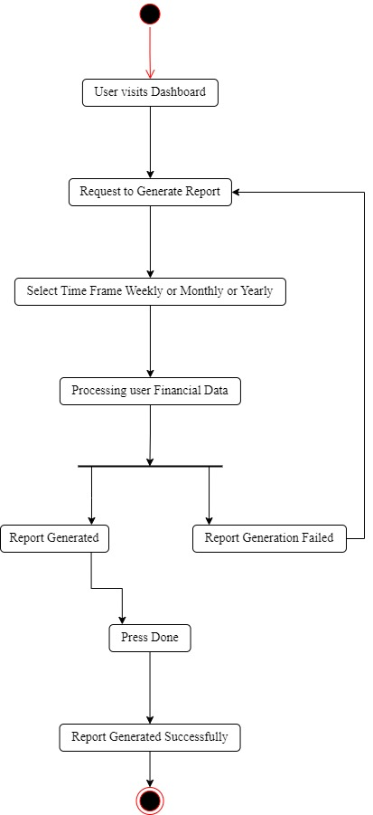

### **State Diagram-8: Forget password**

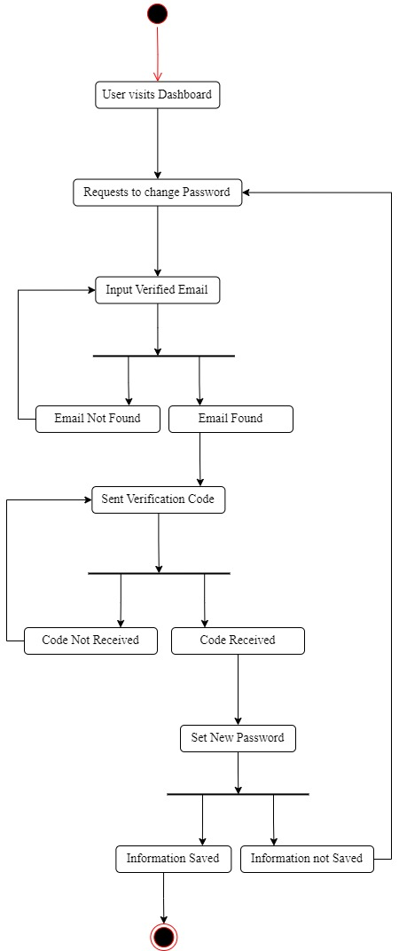

## **Sequence Diagram**

### **Sequence Diagram-1: Add Profile**

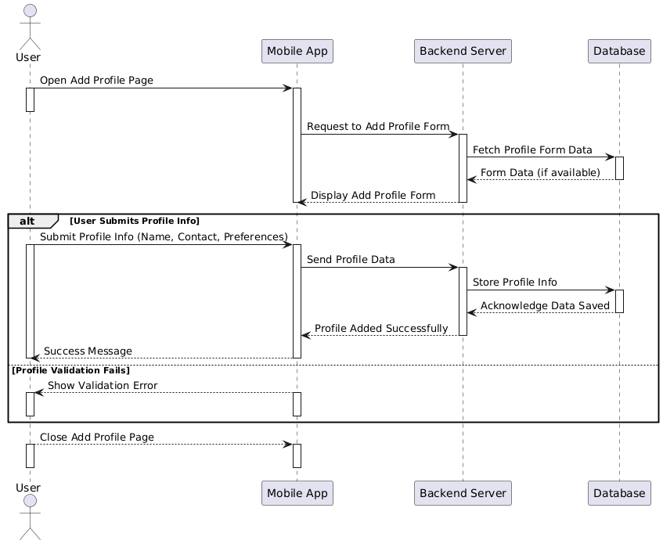

### **Sequence Diagram-2: Add Expense**

### 

### **Sequence Diagram-3: Set Financial Goal**

### **Sequence Diagram-4: Financial Advice**

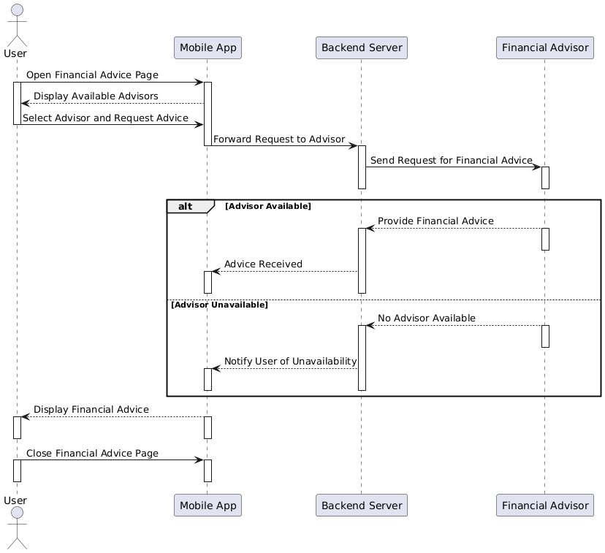

### **Sequence Diagram-5: Donation**

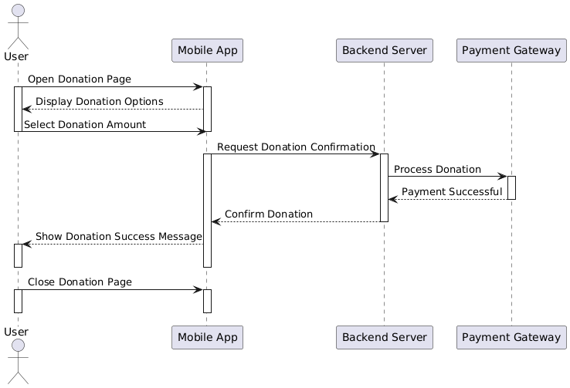

### **Sequence Diagram-6: Data Management**

### **Sequence Diagram-7: Generate Reports**

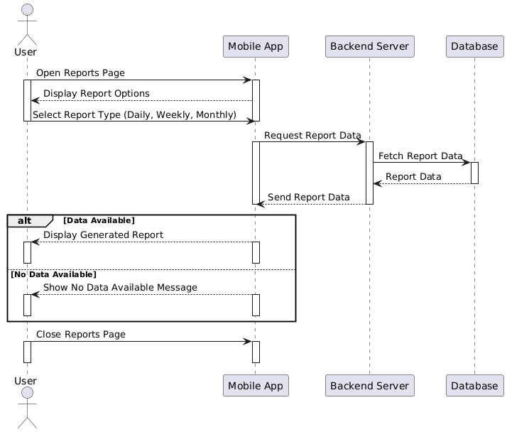

### **Sequence Diagram-8: Forget Password**

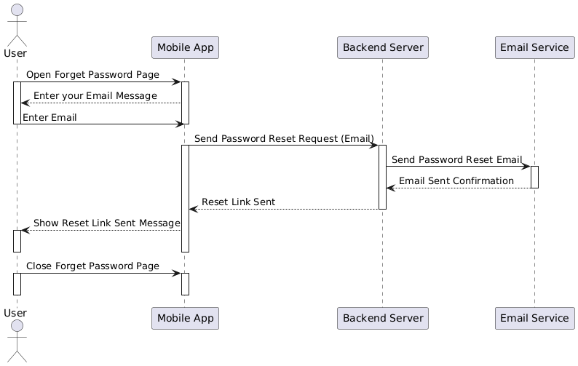

## **Class Diagram**

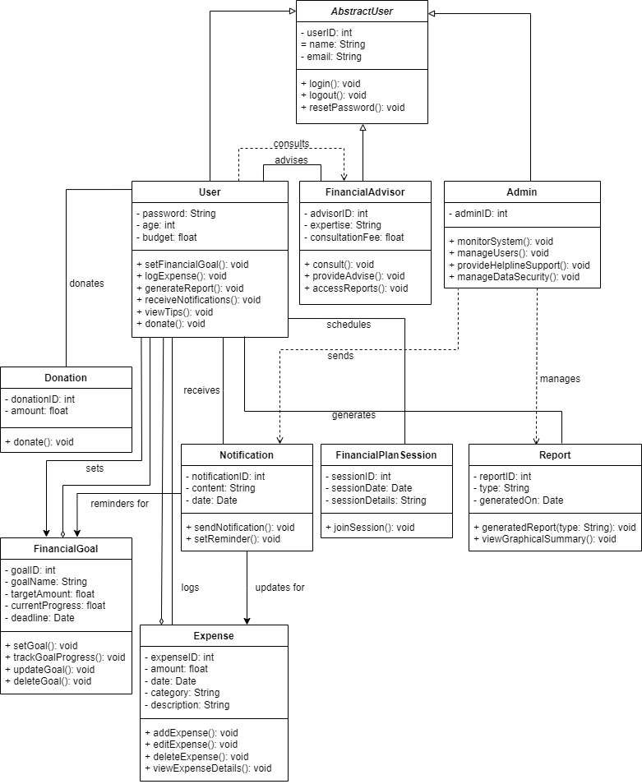

**Figure: Class Diagram for Daily Expense Tracker App**

## **ER Diagram**

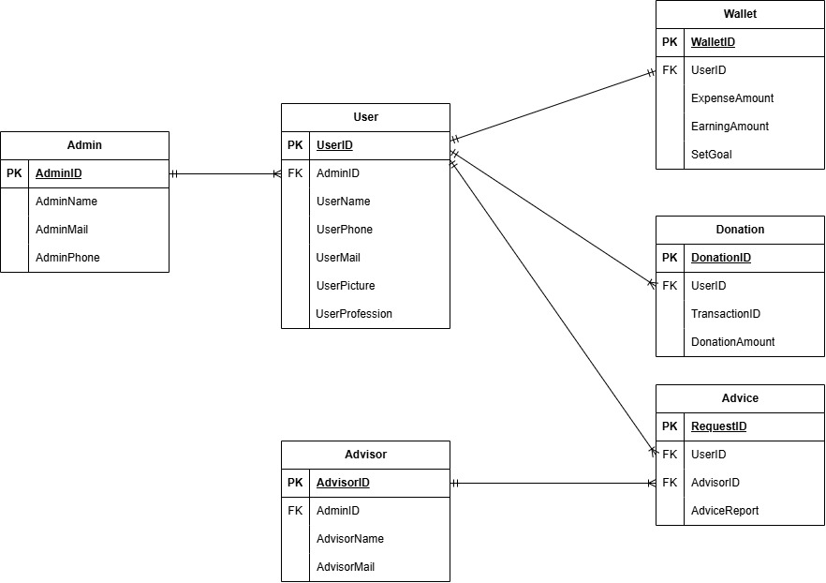

**Figure: ER Diagram for Daily Expense Tracker App**